Income Opportunities For Your Farm: Alternative Enterprises & Agritourism Resources Jan 7, 2007 - 6:06:09 PM
The CD “Income Opportunities For Your Farm: Alternative Enterprises & Agritourism Resources” contains numerous publications including “Taking the First Step”, “Building a Sustainable Business” and many others. There are also links to additional web resources and publications and information about potential funding sources. “Income Opportunities For Your Farm” is currently only available on CD-ROM. Supplies are limited.
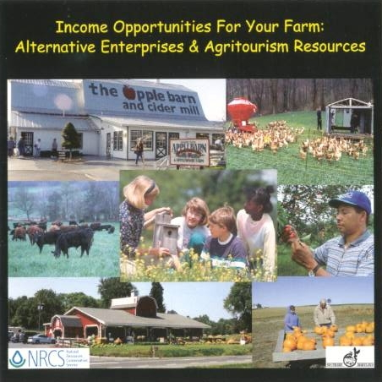

© Copyright 2007 by Southern Maryland RC&D

