Living Shorelines: A more natural erosion control alternative Nov 5, 2010 - 1:30:54 PM
Southern Maryland is no stranger to waterfront property and all of the good and bad associated with it. Shoreline erosion and loss of property affect many areas throughout our region. Though erosion is a natural process, if the rate of erosion is causing a problem or significant loss, than corrective measures may need to be implemented. Depending on the amount and rate of erosion, non-structual or structural methods can be used to stabilize a shoreline.
Living shorelines, a non-structural alternative to hardening the shoreline with bulkheads, revetments or breakwaters, use vegetation and other natural materials to help protect shorelines from excessive erosion while allowing the shoreline to retain its dynamic nature and habitat features. In addition to reducing erosion, a living shoreline can also increase habitat, increase property value, minimize pollution, clean air, and improve the aesthetic of the shoreline (Maryland DNR).
Southern Maryland RC&D, for example, partners with the US Navy, Soil Conservation Districts, private firms and the National Aquarium of Baltimore to implement shoreline stablization measures at several Naval installations here in our region. Because of the high wave energy, we use a hybrid approach where possible to both stabilize the shoreline with structural support and provide a living shoreline habitat beneficial to the ecosystem and aesthetic of the shoreline.
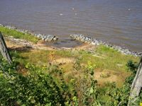
Click image to view larger
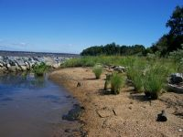
Click image to view larger.

A lot of resources are available on the web if you think a Living Shoreline approach might be right for your property. To learn more, we recommend you start here.
Maryland Department of Natural Resources:
What are the benefits of constructing a living shoreline?
Living Shorelines: A guide for waterfront property owners
Shoreline Management

Eastern Shore Resource Conservation & Development Council
Living Shorelines

Chesapeake Bay Foundation
In Your Backyard

Chespeake Bay Trust
Living Shoreline Design Information

National Oceanic and Atmospheric Administration (NOAA)
The Benefits and Drawbacks of Living Shoreline Erosion Control Methods

Virginia Institute of Marine Science: Center for Coastal Resources Management
Living Shorelines 2010: Why a Living Shoreline

Environmental Protection Agency (EPA)
Adaptation Options for Maintaining Shoreline through Soft Measures

© Copyright 2010 by Southern Maryland RC&D

